# Activity 4 – 24354 (v2) Demonstrate knowledge of and apply safe working practices in a BCATS environment

|  |
| --- |
| **Student name:** |

(A first aid manual may be used.)

**Scenario** – A pallet of timber tips off the forklift, crushing the leg of a workmate.

1. Explain the steps that should be taken to:

Get help:

Administer first aid:

Moving the load:

1. In the space provided below, detail the information that you would give the operator when calling for an ambulance. The operator will also assist you to provide the services with the information required.

|  |
| --- |
|  |

1. The following page is a newspaper article describing an accident that happened in a timber mill. Read the report and answer the following questions.

**My mate saved my scalp when he put it on ice**

*Exclusive by* ***LEE UMBERS***

Scalping survivor Rainier Raharuhi will return to work this week after recovering from one of New Zealand’s horrific industrial accidents.

With him will be league representative and former Mongrel Mobster Morgan Peke who helped save his workmate’s scalp and maybe his life.

Peke, 30, fetched ice from a local pub to preserve the scalp for surgeons and swathed Raharuhi in bandaging to stem blood loss.

The one-time gang hardman also cuddled his colleague for nearly an hour, willing him to stay strong until the air ambulance arrived to rush him to Waikato Hospital.

Working on the grading table at National Park’s Tongariro Sawmills, Raharuhi, 25, noticed a piece of wood blocking the conveyor belt.

He crawled under the table to free it but his long hair, tied in a bun, got caught on the transmission drive.

“Raharuhi says. “I put I could feel my scalp ripping off, “I put my hand up to my head and I could feel flesh and bone. I could feel the air on my brain”. Panicked, he ran for help.

Peke, a table supervisor, heard colleagues’ horrified yells and set off after Raharuhi.

“I could see Rainer running,” he says. “I could see his skull and his face peeling off. “There was nothing holding the skin, his face and the back of his neck were curling up. I grabbed his face and pulled the skin back up’.

Raharuhi had been scalped from his eyebrows to the nape of his neck and his right ear torn off.

Blood from the wounds had soaked his bush shirt, and Peke covered his colleague’s head in tea towels to stem the flow.

As shock wore off Raharuhi went into convulsions and Peke cradled his mate in his arms for almost an hour until paramedics arrived

“Rainier’s body was jumping off the ground and his legs were spinning”, Peke says. “I just grabbed him and held him into me. I said, “You’ll be right bro”.

When ambulance officers arrived, Peke jumped in his car and raced to the local pub to get ice to pack Raharuhi’s scalp in – an action, which helped, save the tissue. Raharuhi has had three major operations to re-attach is scalp and ear. He will have more plastic surgery over the next several months, including a facelift and the re-building of an eyebrow and his hairline.

“The surgeons think once the scarring goes, in maybe up to two years, people might not even notice after my hair grows back” Raharuhi says.

Raharuhi is also grateful to his employer, Taranaki Sawmills (Tongariro Sawmills, parent company) which provided his partner and other family members with accommodation to be with him during his hospital stay and a caregiver for his young daughter.

The Occupational Safety and Health Service have praised Taranaki Sawmills, which also immediately provided trauma counsellors for mill staff, for its compassion.

Emergency stop controls have been improved at the mill since the accident and changes made to machinery to reduce the likelihood of timer jam-ups.

OSH, however, accepts the company did have acceptable safety mechanisms but Raharuhi contravened procedure in his enthusiasm not to hold up mill operation.

The accident was a reminder “no job’s worth dying for”, Lambie says.

Peke is eagerly awaiting his colleague’s return. A former Manawatu league lock and Mongrel Mob member, Peke has seen his share of injuries but says Raharuhi’s ordeal is “the worst thing I’ve been through”.

Watching his mate’s courage recovery had “made my heart a bit softer”.



*SURVIVOR: Rainier Raharuhi says his accident has changed his life.*

*“I put my hand up to my head and I could feel flesh and bone. I could feel the air on my brain”.*

**Surgery Saves Life**

Re-attaching Raharuhi’s scalp and right ear was an eight-hour intricate operation. It was performed under a microscope with 20-times magnification. Waikato Hospital consultants Michael Klaassen and Stuart McNicoll carried out the surgery. The pair sent eight hours taking vein grafts from the injured timber mill worker’s arms and using them to re-attach his scalp and ear.

Their first priority was to re-attach blood vessels to get life saving blood pumping again. Because the scalp had been torn, the vessels in the major vein and artery were damaged.

The consultants grafted 15cm lengths of vein from both arms and used 7cm lengths to re-join the torn artery and vein.

They were sewn together by about 10 stitches, each finer than a hair. There were six joins.

Luckily the blood began pumping again almost immediately. The surgeons used 70 stitches to rejoin the scalp to the head.

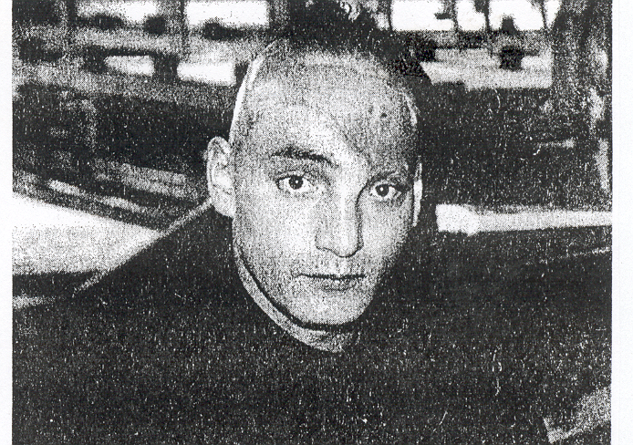

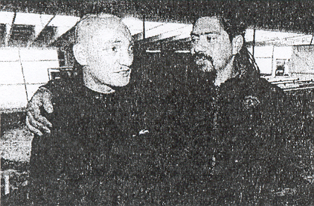

### **Questions**

1. How did this accident occur?

|  |
| --- |
|  |

1. How could it have been avoided?

|  |
| --- |
|  |

1. What first aid was carried out?

|  |
| --- |
|  |