# Activity 1 – 24353 (v2) Demonstrate knowledge of and create sketches and drawings for BCATS projects

|  |
| --- |
| **Student name:** |

1. Sketch and render a pictorial view of the bowl shown below.

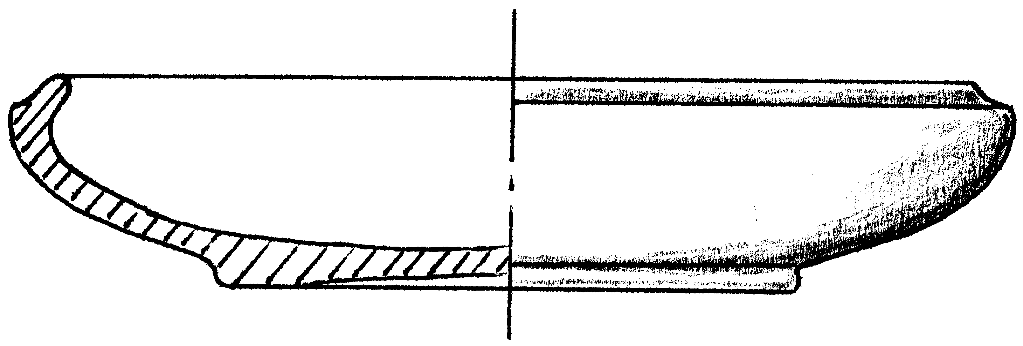

|  |
| --- |
|  |

1. Produce a pictorial sketch of the blanket box, shown to the right. Modify the design to show a solid plinth (base). The box is 750mm long x 400mm wide x 450mm high. Add these dimensions to the sketch.

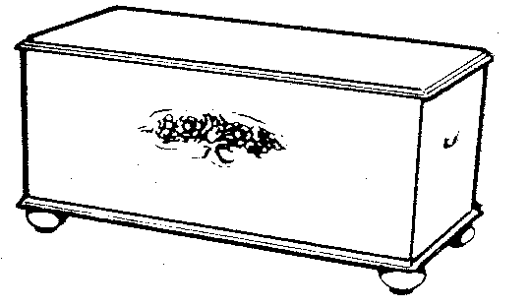

|  |
| --- |
|  |

1. The box has dovetail joints. Sketch a corner joint in exploded view and include at least two dovetails.

|  |
| --- |
|  |