Knowledge assessment – 22607 (v4) Read and interpret plans, working drawings and specifications for BCATS projects

Student Name:

- What does a scale of 1:20 mean?

- What drawing scale would be used where an object is to be drawn showing it twice its actual size?

- What does a thin line with a series of long and short dashes mean?

- What is the purpose of a cross-sectional drawing?

- What type of drawing can provide information about window and door heights?

- Complete the following table:

Symbol/abbreviation | Meaning
 | Door
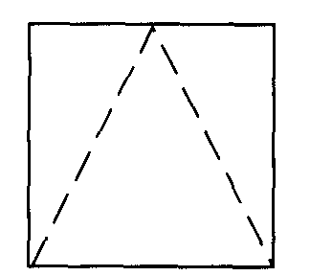
 | Electrical socket outlet
H
C
WM
RSD
 | Underground

- What are 4 main functions of plans, working drawings, and specifications?

1.

2.

3.

4.

- List 3 types of drawings that may form part of a set of working drawings.

1.

2.

3.

- What are 2 advantages of preparing a schedule of quantities?

1.

2.

- From the supplied plans and specifications, answer the following questions:
How many anchor piles are required for the foundation?
What is the size of the anchor pile footing?
What is the scale of the foundation plan?
What is the scale of Cross Section E?
What are the sizes of the following framing members?
- Deck bearers
- Floor joists to main house
- Roof purlins
What is the area of the East Deck?
What is the pitch of the roof?
What fastenings are specified for roof purlins?
What interior linings are specified behind the shower lining?
What interior flooring is specified?
What product is to be placed as a hearth under the fire?

Assessor comments and sign off:
Comments:
Assessor name: …………………………………………………………………………..  Assessor signature:……………………………………………………  Date:…………………….. | RESULT:  A = Achieved,  N = Not Yet Achieved

