# Knowledge Assessment 1 – 24361 (v3) Apply mathematical processes to BCATS projects

|  |
| --- |
| **Student name:** |

**Situation** 1. You have been given the following specifications and asked to construct a coffee table. The tabletop is to be constructed out of solid rimu – ex 160 x 25.

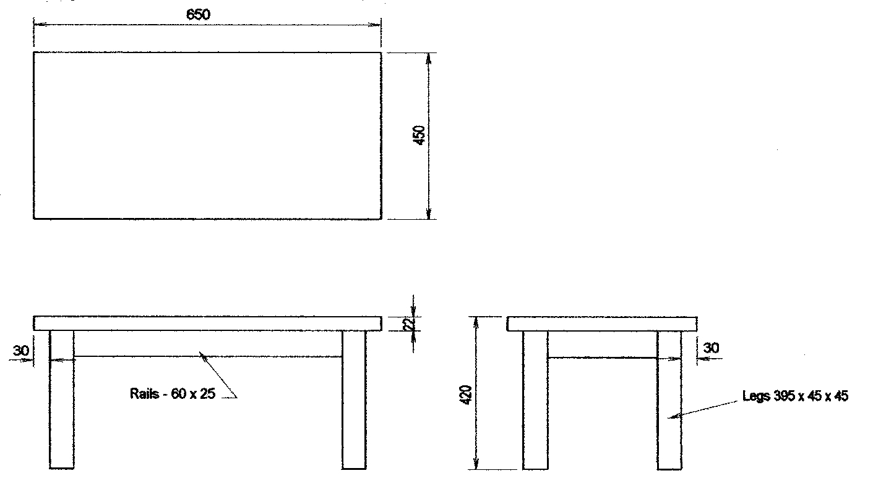

Work out the amount of timber (quantities, sizes etc) required. Show your calculations.

|  |
| --- |
|  |

1. From your calculations, complete the following cutting list for the timber for the coffee table.

|  |  |  |  |  |  |
| --- | --- | --- | --- | --- | --- |
| **Part** | **Number of** | **Length** | **Width** | **Thickness** | **Total length** |
| Top |  |  |  |  |  |
| Side rails |  |  |  |  |  |
| End rails |  |  |  |  |  |
| Legs |  |  |  |  |  |

**Situation 2**. The drawing below shows the outline of a roof section. From the information given answer the following and show your working.

5.600

=

=

1.200

C

A

B

22°

1. Using Pythagoras theorem, calculate the length of the rafter A – C.

|  |
| --- |
|  |

1. Using the triangle theorem, calculate the angle CAB.

|  |
| --- |
|  |

**Situation 3.** The curved section of a residential garden is to be retained using a simple timber post and rail retaining wall.

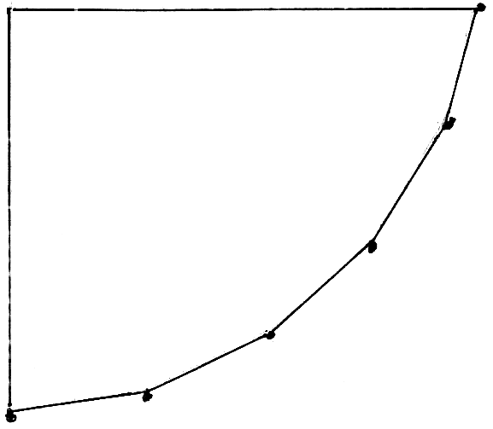

1.200

**Job specifications**

Posts 100 x 100 D45 H4 treated

Retaining timber 200 x 50 D45 H4 treated

Concrete Will be purchased

1. Calculate the quantity of timber and concrete materials required. Show your working.

|  |
| --- |
| 0.600  0.600  GL  GL  Backfill  Retaining timber  Geotextile fabric  Drain coil  Pile hole (200 x 200)  Capping (200 x 50) H4 |

1. From your calculations complete the following materials list.

|  |  |  |  |
| --- | --- | --- | --- |
| **Part** | **Number of** | **Size** | **Totals** |
| Rails |  |  |  |
| Capping |  |  |  |
| Posts |  |  |  |

**Situation 4.** A rectangular area that is 3.750m x 5.250m is to be paved with 150 x 150 x 0.40 concrete paving slabs that cost $2.10 each.

The edge restraint timber is 150 x 50 and a decorative timber inlay strip is to be inserted diagonally from corner to corner.

1. Calculate the total number of paver slabs required and how much will they cost.

|  |
| --- |
|  |

1. Calculate the total length of edging timber required.

|  |
| --- |
|  |

1. Calculate the length of decorative inlay strip needed.

|  |
| --- |
|  |

Assessor comments and sign off:

|  |  |
| --- | --- |
| **Comments:** | |
| Assessor name: ………………………………………………………………………….  Assessor signature:……………………………………………………  Date:…………………….. | RESULT: A = Achieved,  N = Not Yet Achieved |