# Knowledge Assessment – 24360 (v3) Demonstrate knowledge of timber and other construction materials used in BCATS projects

|  |
| --- |
| **Student name:** |

1. Describe these types of timber.

|  |  |
| --- | --- |
| **Timber type** | **Description** |
| Indigenous |  |
| Exotic |  |
| Imported |  |
| Hardwood |  |
| Softwood |  |

1. What type of timber comes from these trees?

|  |  |
| --- | --- |
| **Tree** | **Type of timber** |
| Radiata pine |  |
| Rimu |  |
| Kauri |  |
| Totara |  |
| Tawa |  |
| Douglas fir |  |
| Kwila |  |

1. Identify the parts of the log.

A

B

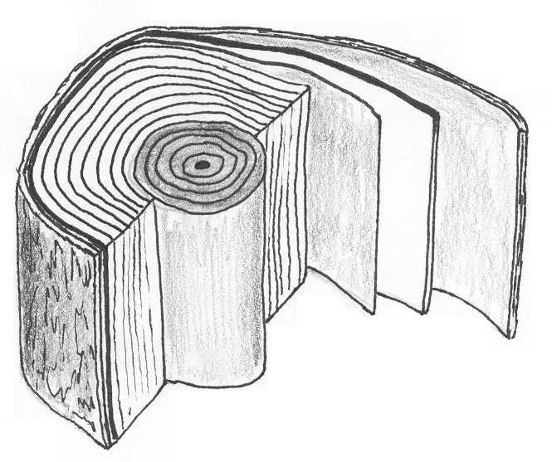

C

E

D

|  |  |
| --- | --- |
| A |  |
| B |  |
| C |  |
| D |  |
| E |  |

1. Compare flat or tangential cut timber with quarter sawn or radial cut. Complete the following sentences.
2. …………………………. cut timber has a better wearing surface.
3. ………………………… cut timber is strong and suitable for beams.
4. The medullary rays on ………………………… cut timber produces an attractive effect on some timbers.
5. Timber cupping away from the heart is more likely with ………………………… cut timber.
6. A large knot is running through the face of a board. List at least two effects this have on the working and structural qualities of the timber.

|  |
| --- |
| 1.  2. |

1. What are these defects?

|  |  |  |
| --- | --- | --- |
| bow |  | end checks2 |
|  |  |  |
| 24360 Split |  | knots |
|  |  |  |

1. What are the signs that timber is affected by:
2. **Borer**

|  |
| --- |
|  |

1. **Wet rot**

|  |
| --- |
|  |

1. Give 4 environmental causes of timber deterioration and describe the effect each has.

|  |  |
| --- | --- |
| **Reason** | **Effect** |
|  |  |
|  |  |
|  |  |
|  |  |

1. What is the difference between rough sawn and dressed timber?

|  |
| --- |
|  |

1. What is the difference between air seasoning and kiln seasoning timber?

|  |
| --- |
|  |

1. Complete the following table.

|  |  |  |
| --- | --- | --- |
| Type of timber treatment | How is it applied to the timber? | Why is the treated timber used? |
| Boron salts |  |  |
| Copper-chrome-arsenate (CCA) |  |  |
| Light organic solvent-borne preservative (LOSP) |  |  |

1. List 3 safe working and handling procedures needed when working with treated timber.

|  |  |
| --- | --- |
| 1. |  |
| 2. |  |
| 3. |  |

1. Why should treated timber never be burned?

|  |
| --- |
|  |

1. Why should fillets be placed between the boards when seasoning?

|  |
| --- |
|  |

1. What are three things that will help protect timber when you are storing it?

|  |  |
| --- | --- |
| 1. |  |
| 2. |  |
| 3. |  |

1. Choose 3 different construction materials and complete the following tables. Examples of construction materials you can choose are below but you are also welcome to write about other ones you may have learned about.

|  |  |  |
| --- | --- | --- |
| * metals | * glass | * composite materials |
| * plastics | * manufactured boards | * concrete |
|  |  |  |

|  |  |
| --- | --- |
| **Material 1 name:** | |
| What is it made of? |  |
| What are its basic structural properties? |  |
| What can it be used for? |  |
| What are 2 tips for handling/working with it safely? |  |
| Describe any special handling requirements. |  |
| How should it be stored? |  |

|  |  |
| --- | --- |
| **Material 2 name:** | |
| What is it made of? |  |
| What are its basic structural properties? |  |
| What can it be used for? |  |
| What are 2 tips for handling/working with it safely? |  |
| Describe any special handling requirements? |  |
| How should it be stored? |  |

|  |  |
| --- | --- |
| **Material 3 name:** | |
| What is it made of? |  |
| What are its basic structural properties? |  |
| What can it be used for? |  |
| What are 2 tips for handling/working with it safely? |  |
| Describe any special handling requirements? |  |
| How should it be stored? |  |

Assessor comments and sign off:

|  |  |
| --- | --- |
| **Comments:** | |
| Assessor name: …………………………………………………………………………..  Assessor signature:…………………………………………………… Date:…………………….. | RESULT: A = Achieved,  N = Not Yet Achieved |