Knowledge Assessment - 24354 (v3) - Demonstrate knowledge of health and safety legislation and apply safe working practices in a BCATS environment

|  |
| --- |
| Student name: |

1. What is the main purpose of the Health and Safety at Work Act 2015 (‘the Act’)?

|  |
| --- |
|  |

1. What are your responsibilities as a “worker” under the Act?

|  |
| --- |
|  |

1. What is a person conducting a business or undertaking’s (PCBUs) main responsibility under the Act?

|  |
| --- |
|  |

1. Complete the following table.

|  |  |  |  |
| --- | --- | --- | --- |
|  | **A. Potential hazard** | **B. Possible harm from the hazard** | **C. Possible control measure** |
| Electrical |  |  |  |
| Chemical |  |  |  |
| Fire |  |  |  |
| Fumes |  |  |  |
| Gas |  |  |  |
| Compressed air |  |  |  |
| Noise |  |  |  |
| Material |  |  |  |
| Falling |  |  |  |
| Lifting |  |  |  |

1. Identify the meanings of the following signs:

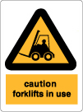

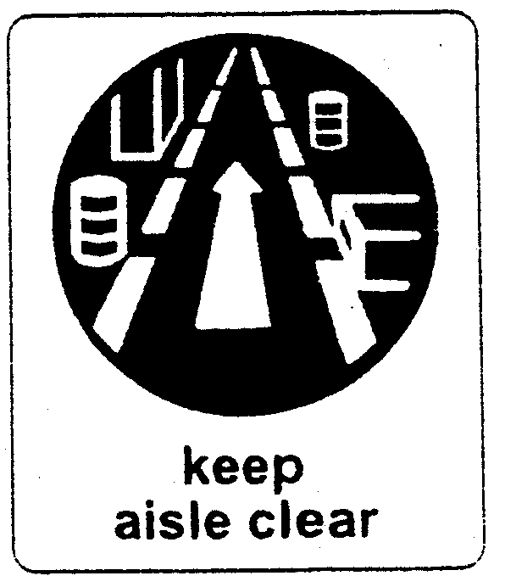

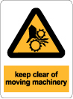

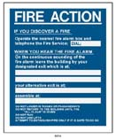

1. Describe the steps you should follow in your workplace in the event of:

a) Fire

b) Earthquake

c) Accident:

d) Chemical spill:

Assessor comments and sign off:

|  |  |
| --- | --- |
| **Comments:** | |
| Assessor name: ………………………………………………………………………….  Assessor signature:……………………………………………………  Date:…………………….. | RESULT: A = Achieved,  N = Not Yet Achieved |