# Activity sheet 4 - 24350 (v2) Identify, select, maintain, and use portable power tools for BCATS projects

|  |
| --- |
| **Student name:** |

1. What safety precautions should be taken before replacing a blade or making adjustments to a power saw?

|  |
| --- |
|  |

1. The dotted line on the drawing below indicates the line to be cut.

**(i)** Identify the supporting features needed to ensure a clean and safe cut:

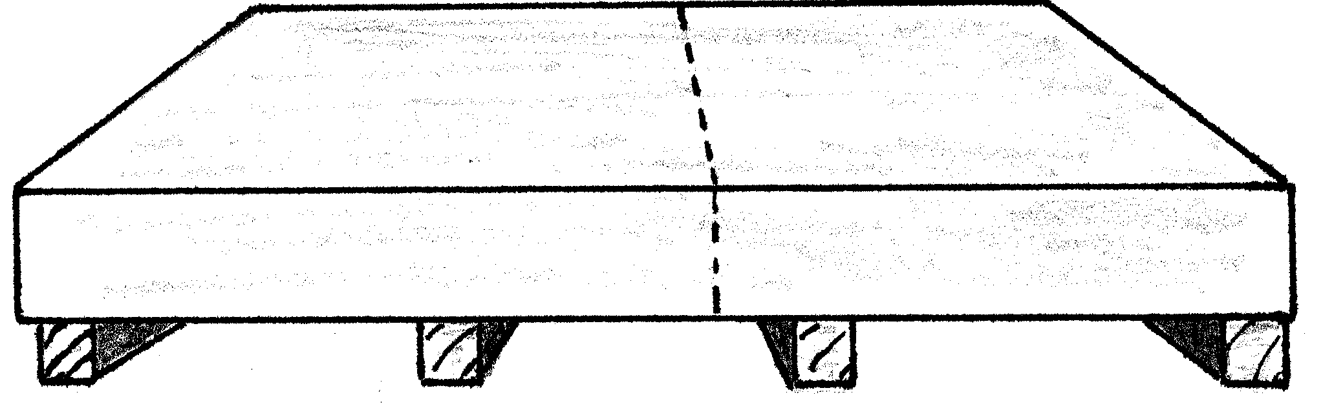

**(ii)** Describe what would happen if any of the supports were omitted:

|  |
| --- |
|  |

Add a sketch to enhance your explanation:

|  |
| --- |
|  |

1. Why is it necessary to hold a portable circular saw firmly with both hands?

|  |
| --- |
|  |

1. What are the potential consequences of using a saw with a faulty or missing lower guard?

|  |
| --- |
|  |

1. Never force the saw. Let the blade do the cutting. Does forcing the cut speed up your productivity?

|  |
| --- |
|  |

1. How does the portable saw differ from the bench model in this regard?

|  |
| --- |
|  |

1. What are the possible consequences of placing a saw down on an exposed blade?

|  |
| --- |
|  |

1. Identify and list **SIX** safety rules applicable to the use of portable circular saws:

|  |
| --- |
| (i) |
| (ii) |
| (iii) |
| (iv) |
| (v) |
| (vi) |